**Objective Questions:**

1. **How can we calculate the total revenue generated by all the sales?**

If we apply the sum function on total sales column then we can find the total revenue generated by all the sales.

Total revenue generated is 107232786.

1. **What is the total number of unique customers who made purchases in each year? Is there any increase in the number over the years?**

2015 - 17624

2016 - 17631

2017 - 17669

2018 - 17352

2019 - 17535

2020 – 25179

If we look at data from 2015 to 2019 the number of customers is approximately same but in 2020 it increased by 40%.

1. **How can we determine the total number of unique products available in the company?**

If we will do a distinct count on the products we will find the number of unique products on amazon.

There are total 44 unique products in the company.

1. **What is the average number of days it takes for products to be delivered, get the metric for only the delivered orders?**

If we will make a new measure with the average function and put a filter of delivered only then we will get our desired result.

it takes around 9.41 days for a product to be delivered which is a successful delivery.

1. **Which products, categories, and subcategories are the most popular?**

**Products-**

Top 5 best selling products are-

1. Avon Soft Musk Eau de Toilette Spray - 50ml **(14444 units)**
2. Triple Power C20 Super Bass USB Bluetooth Subwoofer - Brown + free S530 V4.0 Bluetooth Headset – Black **(14392 units)**
3. Fashion 4-Piece Leather HandBag Set – Black **(14391 units)**
4. Yazole Leather Wrist Watch – Black **(14389 units)**
5. B5 HiFi 5.0 Ture Wireless Headsets Auto Pair Touch – Black **(14331 units)**

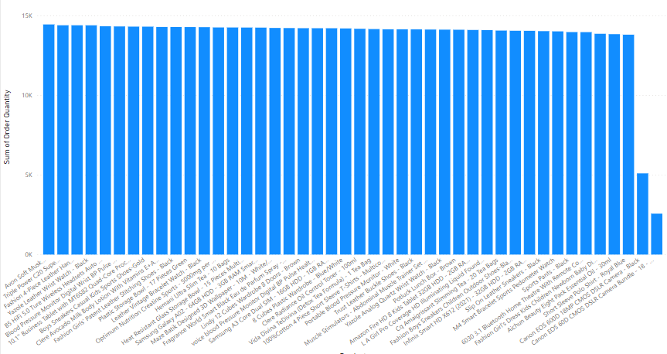

**Categories-**

1. Health and beauty **(35951 order)**
2. Fashion **(33383 order)**
3. Phones and Tablet **(17977 order)**
4. Home and office **(15408 order)**
5. Electronics **(10271 order)**

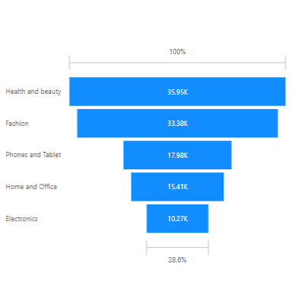

**Sub- Categories-**

Top 5 best selling sub-categories are-

1. Vitamins & Dietary Supplements **(12838 order)**
2. Men's fashion **(10272 order)**
3. Medical supplies and Equipment **(7707 order)**
4. Beauty and personal care **(7704 order)**
5. Boy's fashion **(7704 order)**

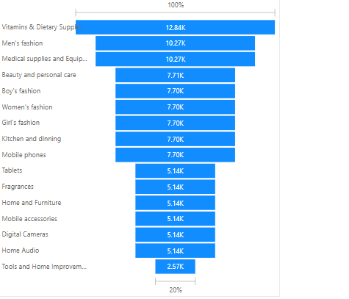

1. **Which products have seen an increase or decrease in sales over the year?**

Most of the products have seen an increase in the sales over the years.

Top 3 top performing products are-

1. Canon EOS 600D 18MP CMOS DSLR Camera – Black
2. Canon EOS 60D CMOS DSLR Camera Bundle - 18 - 55mm Lens - Black
3. Amazon Fire HD 8 Kids Tablet 32GB HDD - 2GB RAM - 8" Blue

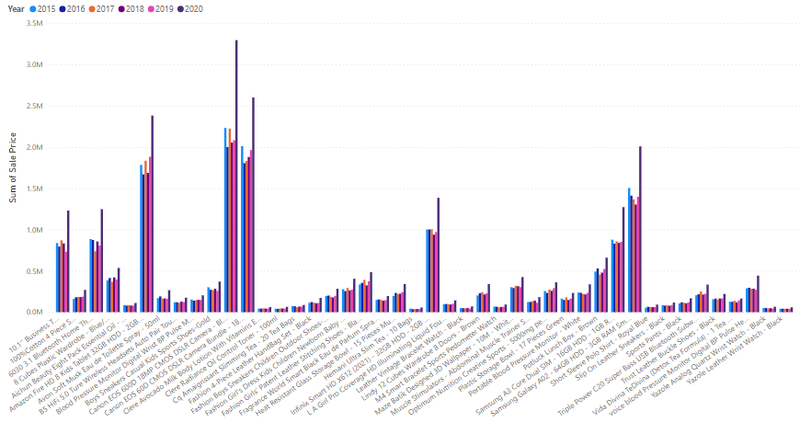

**Subjective Question:**

1. **How does revenue break down by year and by-product? Evaluate how different products contribute to annual revenue and come up with suggestions to increase the sales of the low-selling items.**



To increase the sales of low selling we can do the following things-

* Give some discounts on those products
* Ensure safe and secure delivery
* Understanding customer need
* Be more realistic on product description

1. **How many products were returned? Examine the possible reasons for returns and consider how this metric could inform improvements in product descriptions or quality control.**

If we see above chart, the most of the reason to return the product is delivery of defected items which would be because of improper handling of the product at the delivery end, which needs to be overcome.

The second reason is description mismatch which could be overcome by being more realistic at the describing the product.

1. **Whenever a customer goes to Amazon, they’ll filter the most rated products in order to buy the better category. Can you verify this using any visualization or table that the ratings of products impact their sales value?**

Ratings of the product don’t impact the sales value as we can see through the above chart that high rated products have low sale value as compared to low rating products.

1. **Investigate how revenue distribution varies across different locations. Explore which geographical areas contribute most to sales and consider the strategic implications for regional marketing and distribution efforts. How might location-based trends inform the company's approach to market segmentation and resource allocation?**

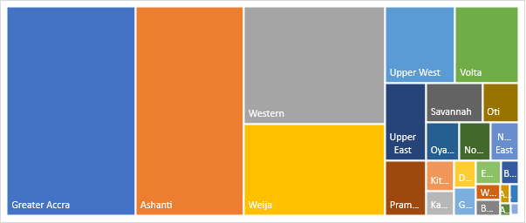

Top 5 high revenue locations are-

1. Greater Accra **(27 million sale value)**
2. Ashanti **(23 million sale value)**
3. Western **(17 million sale value)**
4. Weija **(13 million sale value)**
5. Upper West **(5 million sale value)**

Company should focus on the above mention location more as they are companies best consumers.

1. **Determine which month could benefit from enhanced promotional offers to boost sales. Can you suggest some targeted marketing strategies here?**

June and September months are low performing.

We can have some sale or additional discounts on cart value to boost the sales.

1. **Identify which products may require increased marketing efforts. Which items have high prices yet underperform in sales?**

Items which have high price but low performance are-

1. Product of unit price 4700 – 2567 units sold
2. Product of unit price 2720 – 5096 units sold
3. **Assess which products should have discounts. How can targeted incentives drive sales and customer loyalty for specific products?**

These two items are least sold products which needs to have discounts to increase their sale -

1. Canon EOS 60D CMOS DSLR Camera Bundle - 18 - 55mm Lens - Black
2. Canon EOS 600D 18MP CMOS DSLR Camera – Black
3. **Come up with a loyalty program to benefit the company’s customers. From the available lot of customers come up with strategies to bucket them and provide benefits under different loyalty programs.**

* The customers who order products with high cart value can be given some discounts to motivate them in buying more.
* Customers having multiple orders can be given concession on shipping charges.
* Products which have high unit price can be shipped freely.
* Those standard deliveries which take less time can have reduced shipping charges.

1. **Wait Times Correlated with Demographics and Care: Explore how average wait times vary across different product categories to optimize scheduling and staffing.**

the above graph will tell us about the relationship between the product category and the average delivery time taken for the delivery of the product.

1. **Explore if there is any relationship between the Delivery type and waiting time between ordering and receiving an item.**

the above graph will tell us about the relationship between the delivery type and the waiting time of the customers.

Express delivery takes less time ,then the standard delivery and the products shipped from outside the country took maximum time to be delivered.

1. **Is there any relationship between shipping charges and product type?**
2. **Come up with strategies to decrease the low rating orders after analyzing different factors like waiting time, shipping type, unit price, etc.**

Following steps could be taken to increase the ratings of low rated products-

* The rates of the low rated product can be decreased
* Their delivery should be more fast
* It should be delivered through express deliveries.